
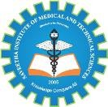
SIMATS ENGINEERING

Saveetha Institute of Medical and Technical Sciences Chennai- 602105
Student Name: DHILIPAN M Reg. No: 192411038
Course Code: CSA0820 Slot: C
Course Name: PYTHON PROGRAMMING FOR SCIENTIFIC COMPUTING Course Faculty: DR.P.VIJAYARAGAVAN AND DR.ARUNA S K
Project Title: AI-Based Smart Irrigation System Using Python and ESP32

Module Photographs:
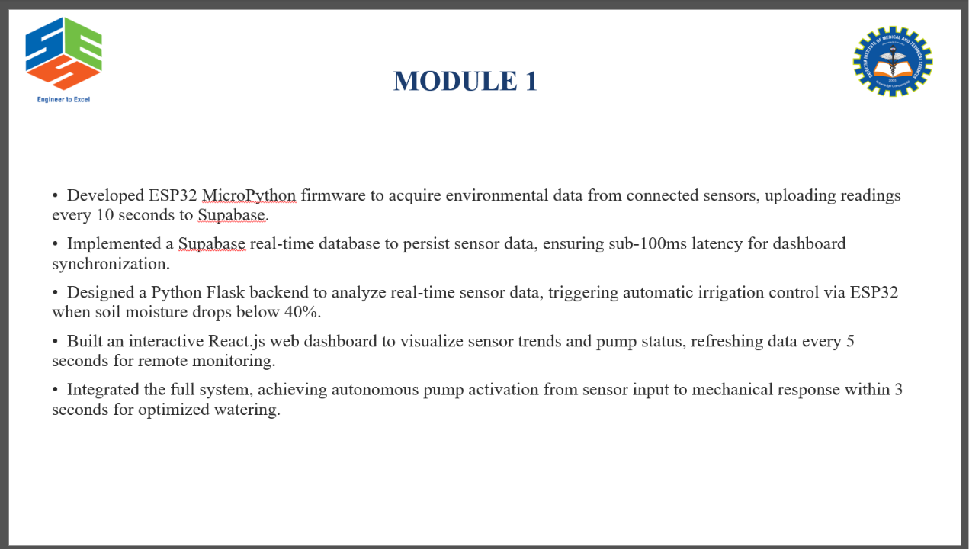 | 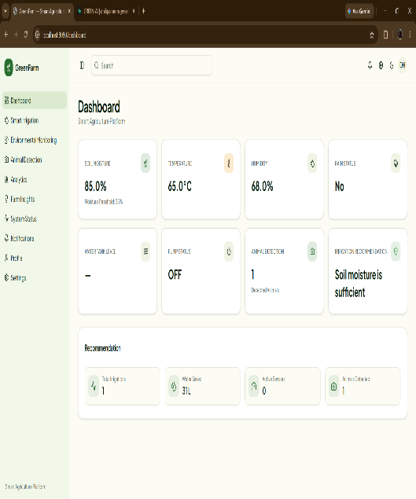 | 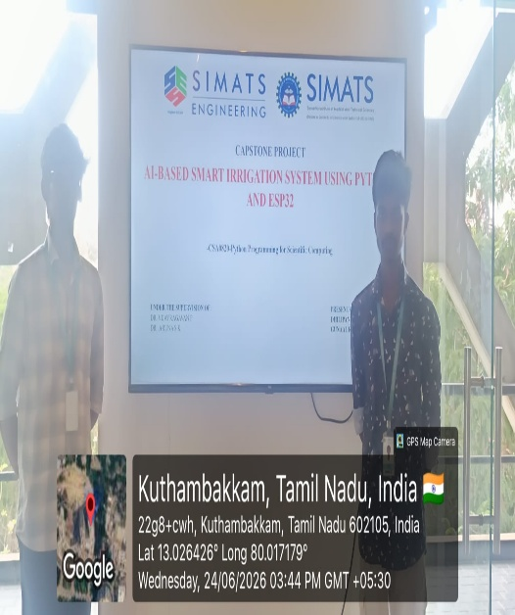
Project Description:
AI-Based Smart Irrigation System Using Python and ESP32 is an innovative IoT-enabled agricultural solution designed to automate irrigation and optimize water usage through real-time environmental monitoring and intelligent decision-making. The system utilizes an ESP32 microcontroller integrated with multiple sensors, including a soil moisture sensor, DHT11 temperature and humidity sensor, rain sensor, water level sensor, ultrasonic sensor, and IR sensor, to continuously monitor field conditions.The ESP32 collects sensor data and transmits it wirelessly to a Python-based application, where the information is processed, stored in a database, and displayed through a web-based dashboard for real-time monitoring. Based on soil moisture levels, weather conditions, and AI-generated recommendations, the system automatically controls a water pump using a relay module, ensuring that crops receive the required amount of water while minimizing water wastage.The system also provides features such as live sensor monitoring, historical data visualization, intelligent irrigation recommendations, water tank level monitoring, and alert notifications for abnormal conditions such as low water levels or animal intrusion. By integrating IoT, Python, database technology, and artificial intelligence, the proposed solution improves irrigation efficiency, reduces manual intervention, conserves water resources, and enhances crop productivity.This smart irrigation system is particularly suitable for agricultural fields, home gardens, greenhouses, research laboratories, and precision farming applications.

Student Signature Guide Signature

